TIME SERIES AND FORECASTING

ASSIGNMENT 3



AUGUSTUS KWAME OWUSU-APPIAH
ALY 6050
STEVEN MITCHELL

Introduction
The food service industry constitutes one of the most significant components of consumer discretionary spending in the United States. Monthly restaurant sales serve as a widely monitored indicator of consumer confidence, disposable income, and broader macroeconomic health. Accurate forecasting of this indicator carries practical relevance for restaurant operators, investors, and policymakers alike.
This study investigates the predictive performance of five time series forecasting methodologies applied to monthly retail sales data for restaurants and other eating places in the United States, sourced from the Federal Reserve Economic Data (FRED) database. The dataset comprises 120 monthly observations spanning January 2010 through December 2019, expressed in millions of dollars on a not-seasonally-adjusted basis. Using 108 months of training data (2010–2018), forecasts were generated for all 12 months of 2019 and evaluated against known actuals using Mean Absolute Percentage Error (MAPE) and Root Mean Square Error (RMSE), with 2019 values held out exclusively for accuracy assessment. Methods examined include Simple Exponential Smoothing (α = 0.7), Double Exponential Smoothing (α = 0.7, β = 0.4), 12-Month Moving Average, 4-Month Weighted Moving Average, and Linear Regression. Solver optimization was additionally applied to exponential smoothing models to identify accuracy-minimizing parameter configurations. Time series decomposition confirmed a multiplicative seasonal structure with a consistent upward linear trend of $206.87 million per month. These findings underscore the critical importance of parameter optimization in exponential smoothing and demonstrate that methods capturing both level and trend components outperform level-only approaches on trended macroeconomic series.
The analytical framework proceeds through four stages:
- Exploratory data analysis and time series visualization to characterize structural properties
- Implementation of forecasting methods with Solver optimization applied to exponential smoothing models
- Comparative accuracy evaluation using MAPE and RMSE
- Synthesis of findings to identify best-performing methods and draw practical conclusions.

Part 1: Data Exploration and Visualization
Time Series Characteristics
The restaurant sales series exhibits three defining structural features upon visual inspection: a sustained upward trend, pronounced annual seasonality, and relatively modest irregular variation. Monthly sales grew from $30,481 million in January 2010 to $54,567 million in December 2018, representing cumulative growth of approximately 79% over the 108-month training window. This growth trajectory reflects long-run real expansion in the restaurant sector driven by population growth, increasing rates of dining out, and rising nominal consumer expenditure.
Seasonal patterns are pronounced and highly regular. Sales consistently reach their lowest levels in January and February, reflecting reduced dining activity during winter months and post-holiday spending contraction and peak during June through August when warmer weather and social activity drive higher dining frequency. This 12-month cycle repeats with high fidelity across all nine training years. Irregular fluctuations are relatively modest, indicating that systematic components dominate random noise and that the series is well-suited to trend-seasonal forecasting approaches.

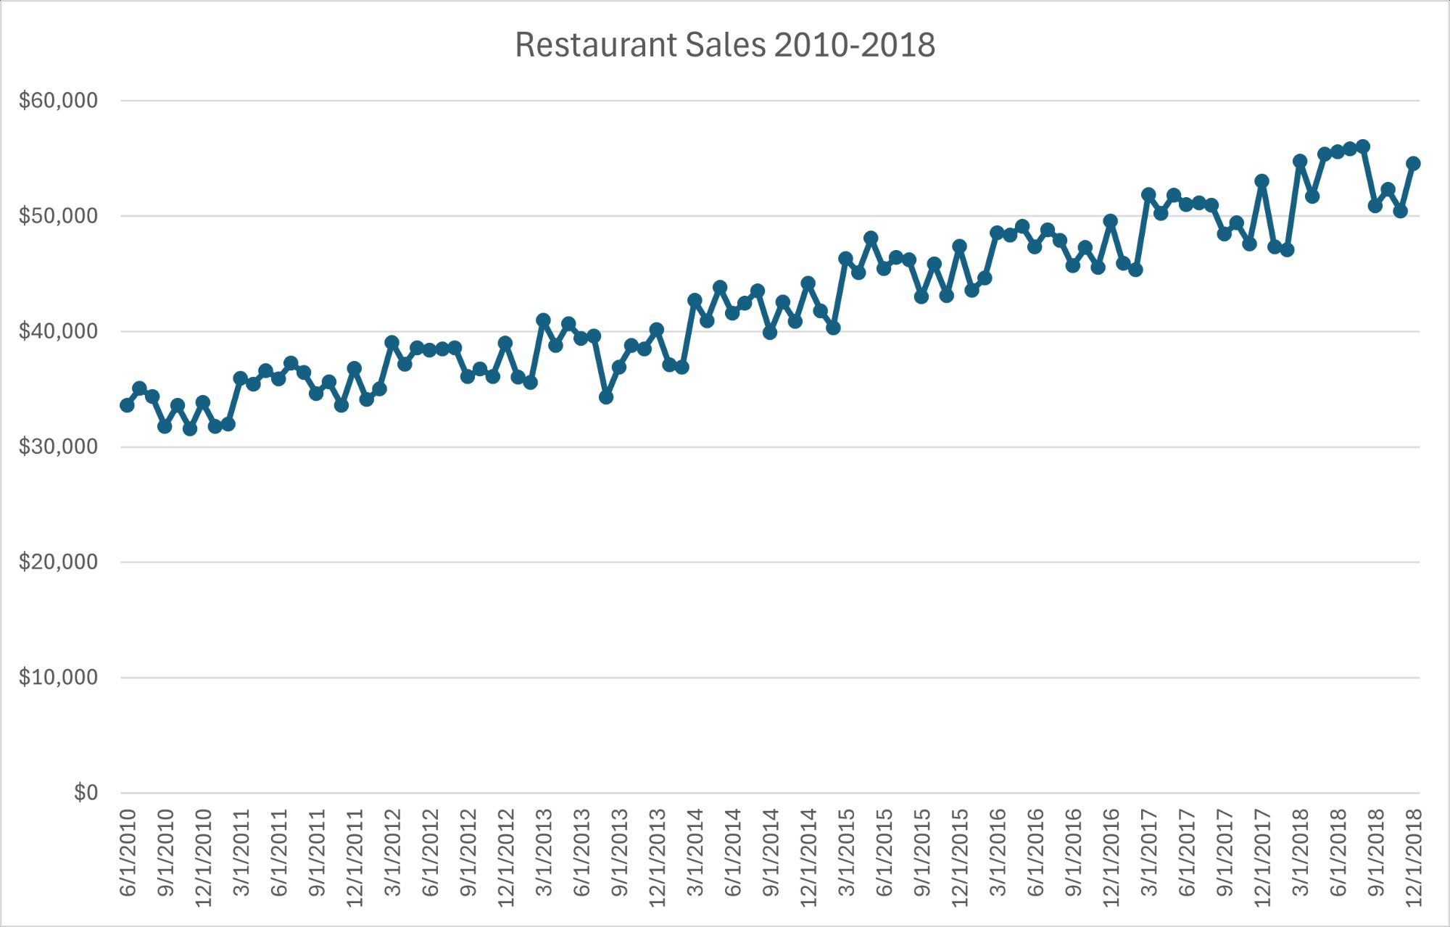
Figure 1. Monthly retail sales at restaurants and other eating places (millions of dollars), January 2010 through December 2018. The series exhibits a consistent upward linear trend superimposed with pronounced annual seasonal variation, peaking in summer months and troughing in January-February each year.
Time Series Decomposition
To formally characterize the structural components, a linear trend was estimated by regressing observed sales values in period numbers 1 through 108. The estimated slope of $206.87 million per month indicates steady monthly growth throughout the training window, with an intercept of $30,910.17 million establishing the baseline level in January 2010.
Both multiplicative and additive decomposition models were evaluated. In the multiplicative model, the seasonal-irregular component is computed by dividing observed values by the trend, yielding proportional seasonal deviation ratios. In the additive model, it is computed by subtraction, yielding absolute deviations. Monthly seasonal indices were computed by averaging the respective seasonal-irregular components for each calendar month across all nine training years using the AVERAGEIF function.
Visual comparison of the two fitted decomposition series overlaid on the original data as shown in Figure 2 reveals that the multiplicative model more closely tracks the observed values, particularly in the later years of the series when seasonal amplitudes grow proportionally with the series level. This finding confirms a multiplicative seasonal structure: seasonal fluctuations scale with the level of the series rather than remaining constant in absolute magnitude. The additive model, which assumes fixed absolute seasonal swings, underestimates seasonal amplitude as the series level rises, producing inferior fit in the 2016-2018 period.
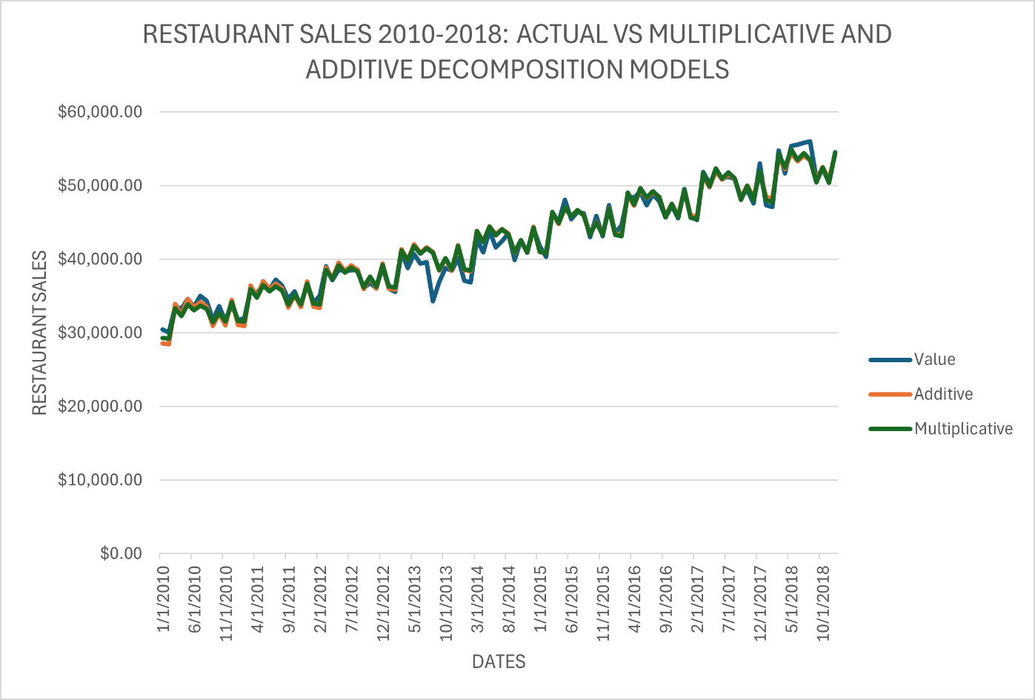
Figure 2. Time series decomposition overlay, 2010-2018. The original Value series is shown alongside the Multiplicative and Additive seasonal model fits. The multiplicative model tracks the original data more closely, particularly in later years, confirming a multiplicative seasonal structure.
Part 2: Forecasting Methods and Results
Simple Exponential Smoothing
Simple Exponential Smoothing (SES) produces forecasts as exponentially weighted averages of past observations using the equation F(t) = α × A(t-1) + (1-α) × F(t-1), where α controls the rate at which historical weights decay. Higher α values place greater emphasis on recent observations while lower values emphasize longer-run averages.
With α = 0.7, the model was fitted to the 108-month training series, initializing the smoothed value at the January 2010 actual of $30,481 million. The final smoothed value produced in December 2018 was $52,441.07 million. Per SES convention, this single value was applied as a static flat forecast for all 12 months of 2019, as SES does not model trend and therefore projects the current smoothed level uniformly into the future.
This flat forecast approach represents a fundamental structural mismatch with the data. Given the persistent upward trend in restaurant sales, projecting a constant level from December 2018 systematically underestimates 2019 values for all months beyond January, with the error growing larger as 2019 progresses and actual values continue rising. Solver optimization identified an improved α of 0.230, which effectively weighs the long-run historical average more heavily than the reactive α = 0.7 default, yielding MAPE = 0.0747 and RMSE = $4,552.94. Table 1 presents the detailed month-by-month results for the default parameterization.
Table 1
Simple Exponential Smoothing (α = 0.7) 2019 Forecast Result
Month | Actual ($M) | Forecast ($M) | MAPE
Jan | $49,445.00 | $52,441.07 | 0.0606
Feb | $49,162.00 | $52,441.07 | 0.0667
Mar | $57,230.00 | $52,441.07 | 0.0837
Apr | $54,723.00 | $52,441.07 | 0.0417
May | $58,681.00 | $52,441.07 | 0.1063
Jun | $57,911.00 | $52,441.07 | 0.0945
Jul | $58,456.00 | $52,441.07 | 0.1029
Aug | $59,213.00 | $52,441.07 | 0.1144
Sep | $53,997.00 | $52,441.07 | 0.0288
Oct | $55,928.00 | $52,441.07 | 0.0623
Nov | $54,579.00 | $52,441.07 | 0.0392
Dec | $57,994.00 | $52,441.07 | 0.0958
Average (2019) | — | — | MAPE: 0.0747 RMSE: $4,552.94

Double Exponential Smoothing
Double Exponential Smoothing (Holt's method) extends SES by maintaining separate smoothed estimates of both the level and trend of the series. The level and trend updating equations are: L(t) = α × A(t) + (1-α) × [L(t-1) + T(t-1)] and T(t) = β × [L(t) - L(t-1)] + (1-β) × T(t-1). The m-step-ahead forecast is F(t+m) = L(t) + m × T(t), projecting the current trend linearly into the future.
With α = 0.7 and β = 0.4, the model was initialized with the level set to January 2010 actual and the trend set to the difference between the first two observations. The final estimated level in December 2018 was L (108) = $53,064.93 million and the final estimated trend was T (108) = $287.92 million per month. The 2019 forecasts were therefore computed as $53,064.93 + m × $287.92 for m = 1 through 12, yielding forecasts ranging from $53,352.86 in January to $56,520.03 in December.
This trend-projecting approach substantially outperformed SES by anticipating continued monthly growth consistent with the historical trend. The default DES achieved MAPE = 0.0476 and RMSE = $2,992.89. Solver optimization identified near-identical optimal parameters of α = 0.712 and β = 0.435, yielding MAPE = 0.0459 and RMSE = $2,862.52.
Table 2
Double Exponential Smoothing (α = 0.7, β = 0.4) 2019 Forecast Results
Month | Actual ($M) | Forecast ($M) | MAPE
Jan | $49,445.00 | $53,496.31 | 0.0819
Feb | $49,162.00 | $53,905.19 | 0.0965
Mar | $57,230.00 | $54,314.07 | 0.0510
Apr | $54,723.00 | $54,722.95 | 0.0000
May | $58,681.00 | $55,131.83 | 0.0605
Jun | $57,911.00 | $55,540.71 | 0.0409
Jul | $58,456.00 | $55,949.59 | 0.0429
Aug | $59,213.00 | $56,358.47 | 0.0482
Sep | $53,997.00 | $56,767.35 | 0.0513
Oct | $55,928.00 | $57,176.23 | 0.0223
Nov | $54,579.00 | $57,585.12 | 0.0551
Dec | $57,994.00 | $57,994.00 | 0.0000
Average (2019) | — | — | MAPE: 0.0459  RMSE: $2,862.52

Moving Average Methods
Two moving average methods were implemented. The 12-Month Moving Average (12-MA) computes the unweighted arithmetic mean of the 12 most recent monthly observations, providing a smoothed estimate that eliminates annual seasonality by equally weighting all months within a year. The 4-Month Weighted Moving Average (4-WMA) applies weights of 0.4, 0.3, 0.2, and 0.1 to the four most recent observations respectively, reflecting the intuition that more recent data carries greater predictive relevance.
For 2019 forecasting, both moving average series computed through December 2018 were used as inputs to a secondary linear trend model. SLOPE and INTERCEPT functions were applied to the historical moving average values and their corresponding period numbers (using only training data), generating a trend line that was then evaluated at periods 109-120 to produce month-by-month 2019 forecasts. This two-stage approach avoids data leakage that would arise from incorporating 2019 actual values into the moving average calculations.
The 12-MA achieved MAPE = 0.054 and RMSE = $3,458.14. The 4-WMA achieved MAPE = 0.049 and RMSE = $3,228.62, modestly outperforming the 12-MA on both metrics. Tables 3 and 4 present detailed results for each method.

Table 3
12-Month Moving Average Trend Line 2019 Forecast Results
Month | Actual ($M) | Forecast ($M) | MAPE
Jan | $49,445.00 | $52,009.21 | 0.0651
Feb | $49,162.00 | $52,215.99 | 0.0748
Mar | $57,230.00 | $52,422.76 | 0.0737
Apr | $54,723.00 | $52,629.53 | 0.0275
May | $58,681.00 | $52,836.30 | 0.0888
Jun | $57,911.00 | $53,043.07 | 0.0720
Jul | $58,456.00 | $53,249.84 | 0.0773
Aug | $59,213.00 | $53,456.61 | 0.0854
Sep | $53,997.00 | $53,663.38 | 0.0079
Oct | $55,928.00 | $53,870.16 | 0.0224
Nov | $54,579.00 | $54,076.93 | 0.0073
Dec | $57,994.00 | $54,283.70 | 0.0460
Average (2019) | — | — | MAPE: 0.054  RMSE: $3,458.14

Table 4
4-Month Weighted Moving Average Trend Line — 2019 Forecast Results
Month | Actual ($M) | Forecast ($M) | MAPE
Jan | $49,445.00 | $53,054.85 | 0.0620
Feb | $49,162.00 | $53,261.69 | 0.0469
Mar | $57,230.00 | $53,468.53 | 0.1184
Apr | $54,723.00 | $53,675.37 | 0.0317
May | $58,681.00 | $53,882.21 | 0.0826
Jun | $57,911.00 | $54,089.05 | 0.0287
Jul | $58,456.00 | $54,295.89 | 0.0174
Aug | $59,213.00 | $54,502.73 | 0.0211
Sep | $53,997.00 | $54,709.57 | 0.0866
Oct | $55,928.00 | $54,916.41 | 0.0164
Nov | $54,579.00 | $55,123.25 | 0.0308
Dec | $57,994.00 | $55,330.09 | 0.0459
Average (2019) | — | — | MAPE: 0.049  RMSE: $3,228.62

Linear Regression
Linear regression modeled the relationship between restaurant sales and time period number using ordinary least squares, fitting the equation Sales(t) = 206.87 × t + 30,910.17 to the 108 training observations. This equation indicates average monthly growth of $206.87 million over the 2010-2018 period, consistent with the decomposition analysis. Forecasts for periods 109-120 (January-December 2019) were computed by evaluating this equation at each period, yielding forecasts ranging from $53,458.63 in January to $55,734.16 in December.
Despite making no accommodation for seasonality, projecting a smoothly increasing series rather than the oscillating seasonal pattern of actual monthly values, regression achieved MAPE = 0.050 and RMSE = $3,153.73, the best performance among non-optimized methods. This result reflects the dominant importance of the trend component in driving forecast accuracy for this series, with seasonal deviations averaging out across the 12-month evaluation window. Table 5 presents detailed results.
Table 5
Linear Regression 2019 Forecast Results
Month | Actual ($M) | Forecast ($M) | MAPE
Jan | $49,445.00 | $53,458.63 | 0.0812
Feb | $49,162.00 | $53,665.50 | 0.0916
Mar | $57,230.00 | $53,872.36 | 0.0587
Apr | $54,723.00 | $54,079.23 | 0.0118
May | $58,681.00 | $54,286.10 | 0.0749
Jun | $57,911.00 | $54,492.96 | 0.0590
Jul | $58,456.00 | $54,699.83 | 0.0643
Aug | $59,213.00 | $54,906.70 | 0.0727
Sep | $53,997.00 | $55,113.56 | 0.0207
Oct | $55,928.00 | $55,320.43 | 0.0109
Nov | $54,579.00 | $55,527.30 | 0.0174
Dec | $57,994.00 | $55,734.16 | 0.0390
Average (2019) | — | — | MAPE: 0.050  RMSE: $3,153.73

Part 3: Comparative Results and Analysis
Table 6 summarizes accuracy metrics for all seven model configurations evaluated, including default-parameter and Solver-optimized versions of the exponential smoothing models. Figure 3 provides a visual comparison of RMSE values across all methods.
Table 6
Forecast Accuracy Summary: All Methods, 2019 Holdout Period
Method | MAPE | RMSE ($M) | Rank
Simple Exponential Smoothing (α = 0.7) | 0.0900 | 5,646.78 | 7
Simple Exponential Smoothing (Solver: α = 0.230) | 0.0747 | 4,552.94 | 6
Double Exponential Smoothing (α = 0.7, β = 0.4) | 0.0476 | 2,992.89 | 2
Double Exponential Smoothing (Solver: α = 0.712, β = 0.435) | 0.0459 | 2,862.52 | 1
12-Month Moving Average | 0.0540 | 3,458.14 | 5
4-Month Weighted Moving Average | 0.0490 | 3,228.62 | 4
Linear Regression | 0.0500 | 3,153.73 | 3

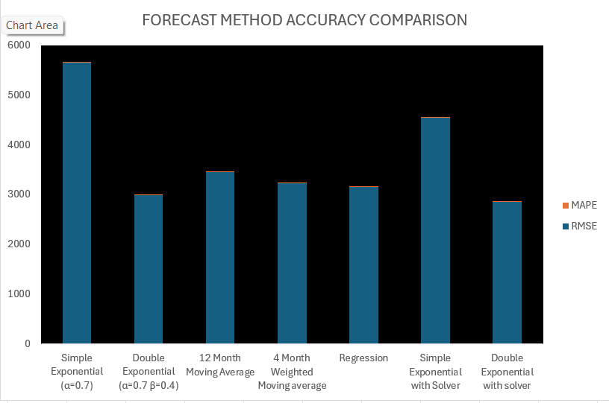
Figure 3. Forecast method accuracy comparison by RMSE across all seven model configurations. Lower RMSE indicates superior forecast accuracy. Solver-optimized Double Exponential Smoothing achieves the lowest RMSE of $2,862.52, while default Simple Exponential Smoothing performs worst at $5,646.78.
Discussion of Results
Several important conclusions emerge from the comparative accuracy analysis.
First, the superiority of Double Exponential Smoothing over Simple Exponential Smoothing across all parameter configurations confirms the theoretical expectation that trend-incorporating methods outperform level-only methods on trended series. The SES flat forecast systematically underestimates later 2019 months as actual sales continue rising, while DES projects the estimated trend slope forward, tracking the continued upward trajectory. This distinction accounts for the substantial difference in performance: DES achieves RMSE of $2,993 versus $5,647 for SES at comparable default parameters.
Second, the near-equivalence of MAPE values around 0.05 for the 12-MA, 4-WMA, and regression methods suggests a performance plateau for methods that lack explicit seasonality modeling. All three generate smooth trend-based forecasts that average over seasonal variation, and their residual errors are driven primarily by month-to-month seasonal fluctuations they do not capture. The RMSE differentiation within this group; Regression ($3,154) outperforming 4-WMA ($3,229) and 12-MA ($3,458) indicates that the linear regression trend more precisely tracks the 2019 trajectory.
Third, Solver optimization materially improved both exponential smoothing models. For SES, optimization reduced MAPE from 0.090 to 0.075 and RMSE from $5,647 to $4,553. For DES, it reduced MAPE from 0.0476 to 0.0459 and RMSE from $2,993 to $2,863. The smaller relative improvement for DES reflects the near optimality of the default parameters, with Solver identifying α = 0.712 and β = 0.435, only marginally different from the defaults of 0.7 and 0.4.
It is important to note that all models evaluated assume structural stability between the 2010–2018 training window and the 2019 holdout period. Forecast reliability depends on the continuation of historical trends and seasonal dynamics. Structural breaks, macroeconomic shocks, or policy disruptions would materially alter forecast performance and should be considered when applying these models in practice.
Conclusion
This study evaluated five forecasting methodologies applied to monthly U.S. restaurant sales data across a 2010-2019 observation window, providing a rigorous multi-method comparison on a real macroeconomic time series.
The Solver-optimized Double Exponential Smoothing model with α = 0.712 and β = 0.435 is recommended as the preferred forecasting approach for this series, achieving the best accuracy across all configurations evaluated (MAPE = 0.0459, RMSE = $2,862.52). From a managerial perspective, improved forecast accuracy has meaningful operational implications. For restaurant operators, more accurate monthly forecasts reduce the risk of labor overstaffing or understaffing, improve inventory purchasing decisions, and enhance short-term cash flow planning. For investors and policymakers, more precise forecasts improve assessments of consumer demand and sector momentum. The reduction in RMSE achieved by the optimized DES model represents economically meaningful improvement in planning precision at scale. For practitioners without optimization tools, the default DES with α = 0.7 and β = 0.4 provides a strong alternative with near-optimal accuracy (MAPE = 0.0476, RMSE = $2,992.89).
Three methodological principles are reinforced by these findings. First, model-data structural alignment is essential: trend-incorporating methods substantially outperform level-only methods on trended series. Second, parameter optimization materially improves exponential smoothing accuracy. Third, the decomposition analysis identifying multiplicative seasonality provides actionable guidance for future model selection, specifically, multiplicative Holt-Winters triple exponential smoothing would be expected to outperform all methods evaluated here by explicitly modeling the seasonal component. A limitation of the present analysis is that none of the implemented forecasting models explicitly incorporated multiplicative seasonality in the forecasting stage, despite the confirmed seasonal structure in the data. While Double Exponential Smoothing performed best among evaluated methods, a multiplicative seasonal exponential smoothing model would likely produce further accuracy gains by directly modeling seasonal scaling effects. Future research could extend this analysis by formally implementing and comparing such models.
References
Federal Reserve Bank of St. Louis. (2024). Retail sales: Restaurants and other eating places (MRTSSM7225USN). FRED Economic Data. https://fred.stlouisfed.org/series/MRTSSM7225USN
Gardner, E. S., Jr. (1985). Exponential smoothing: The state of the art. Journal of Forecasting, 4(1), 1-28. https://doi.org/10.1002/for.3980040103
Holt, C. E. (2004). Forecasting seasonals and trends by exponentially weighted moving averages. International Journal of Forecasting, 20(1), 5-10. https://doi.org/10.1016/j.ijforecast.2003.09.015
Hyndman, R. J., & Athanasopoulos, G. (2021). Forecasting: Principles and practice (3rd ed.). OTexts. https://otexts.com/fpp3/
Makridakis, S., Wheelwright, S. C., & Hyndman, R. J. (1998). Forecasting: Methods and applications (3rd ed.). John Wiley & Sons.
Montgomery, D. C., Jennings, C. L., & Kulahci, M. (2015). Introduction to time series analysis and forecasting (2nd ed.). John Wiley & Sons.
U.S. Census Bureau. (2024). Monthly retail trade survey. United States Department of Commerce. https://www.census.gov/retail/index.html

